Norwalk City School District

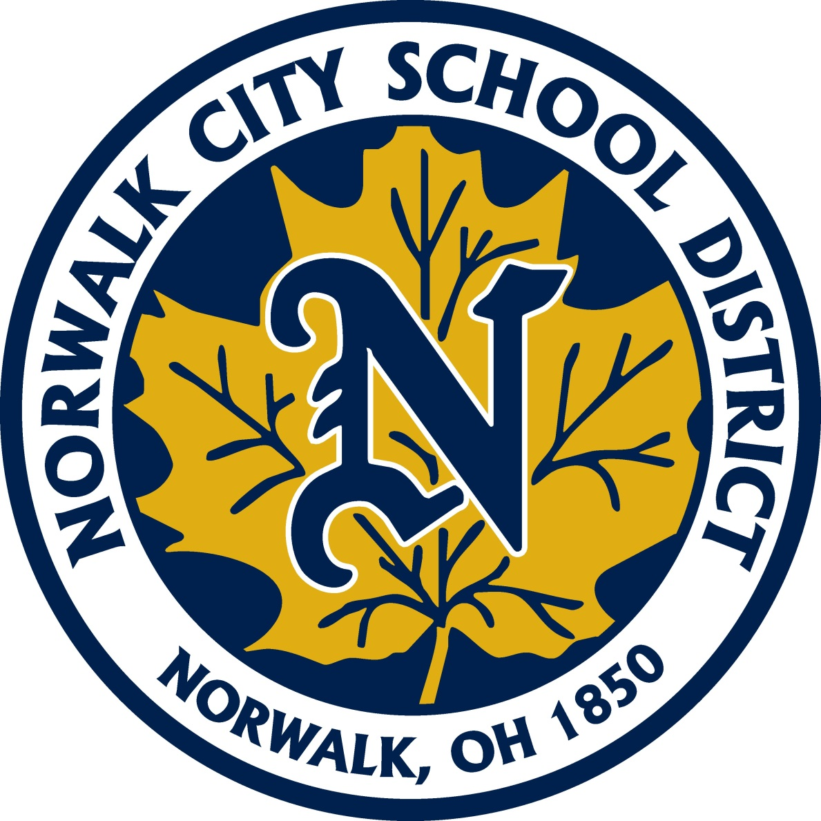

Title I

Norwalk City School District
Federal Programs
Title I

Mr. Dan Bauman
Title I Coordinator
baumand@norwalktruckers.net

What is Title I?
Title I, Part A (Title I) of the Elementary and Secondary Education Act, as amended by the Every Student Succeeds Act (ESEA) provides financial assistance to local educational agencies (LEAs) and schools with high numbers or high percentages of children from low-income families to help ensure that all children meet challenging state academic standards. Federal funds are currently allocated through four statutory formulas that are based primarily on census poverty estimates and the cost of education in each state.

All kindergarten through sixth grade students are a part of a school-wide Title I Program. Title I services are provided to support our students’ progress and achievement in the areas of Reading and Math. During the course of the school year, your child may be provided assistance with various skills. This could be for extra support, assistance or enrichment.

This year, for our Title I Program, we will be working with individual/small group instruction several days per week and whole class instruction and co-teaching. We will be targeting students based primarily on iReady assessments, teacher recommendations and AIR Assessment scores. Our goal is to assist as many students as possible and increase academic growth. This assistance will be provided during the regular school day.

Maplehurst Elementary

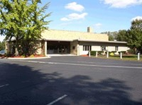

Mr. Ken Moore – Principal
moorek@norwalktruckers.net

Mrs. Tracy Heyman – Title I Teacher
heymant@norwalktruckers.net

Mrs. Tiffany Lloyd – Title I Teacher
lloydt@norwalktruckers.net

Mrs. Stephani Underwood – Title I Teacher
underwos@norwalktruckers.net

Pleasant Elementary

Mrs. Janice Smith – Principal
smithj@norwalktruckers.net

Mrs. Tracy Heyman - Title I Teacher
heymant@norwalktruckers.net

Mrs. Amy Mayer - Title I Teacher
mayera@norwalktruckers.net

Mrs. Alyssa Valentine - Title I Teacher
valentinea@norwalktruckers.net

League Elementary

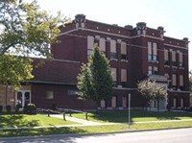

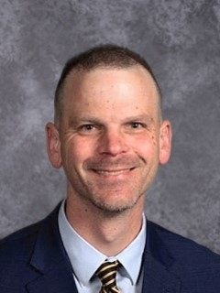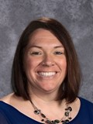

Mr. Nick Kish – Principal
kishn@norwalktruckers.net

Mrs. Robyn Rogers - Title I Teacher
rogersr@norwalktruckers.net

Main St. School

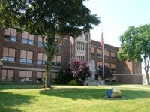

Mr. Rick Hudgel – Principal
hudgelr@norwalktruckers.net

Mr. Luke McCoy - Title I Teacher
mccoyl@norwalktruckers.net

